Kubernetes Task-10
- Setup eks cluster using eksctl
- setup eks cluster using console
- Setup HPA
- Setup cluster autoscale
- Setup cronjob and job
- Create secret and inject inside pod
- Check different add-ons available on eks.
- Upgrade eks cluster

Task 1: Setup EKS Cluster Using eksctl

Objective
Create a functional Amazon EKS cluster using eksctl, including the EKS control plane and worker nodes, and verify that Kubernetes workloads can be deployed to the cluster.

Implementation Steps

1.1 Verify prerequisites
Make sure the following are installed and configured on your machine:
- AWS CLI
- eksctl
- kubectl
Verify:
aws --version
eksctl version
kubectl version –client

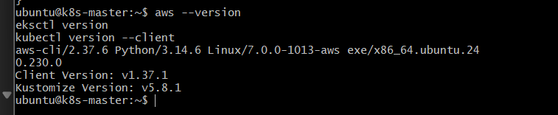

1.2 Configure AWS credentials
aws configure
Provide:
AWS Access Key ID:
AWS Secret Access Key:
Default region name: us-east-1
Default output format: json
Verify:
aws sts get-caller-identity
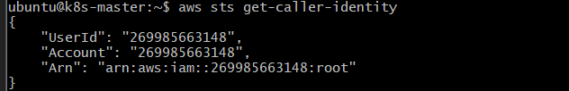

1.3 Create the EKS cluster
Create the cluster using eksctl:
eksctl create cluster \
--name eksctl-demo \
--region us-east-1 \
--nodegroup-name worker-nodes \
--node-type t3.medium \
--nodes 2 \
--nodes-min 2 \
--nodes-max 3 \
--managed

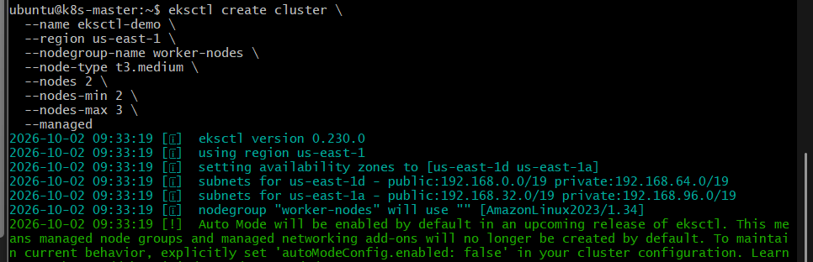

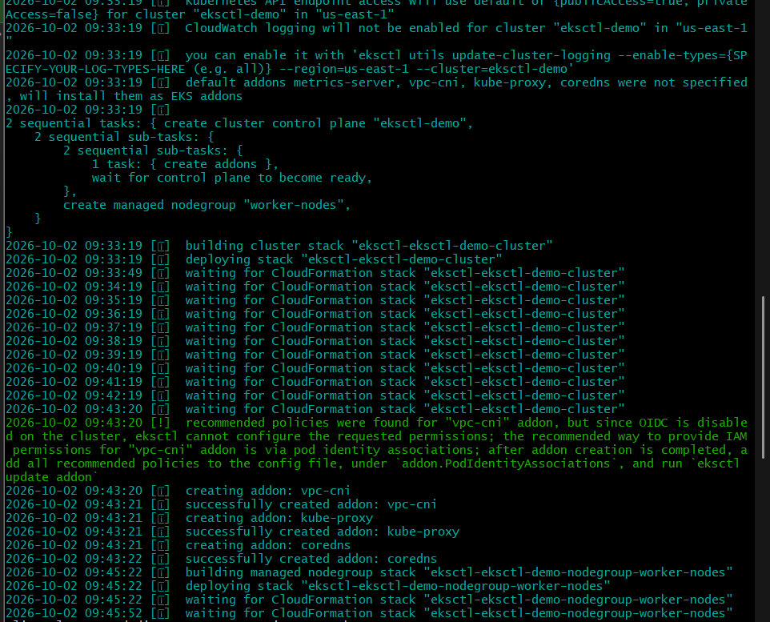

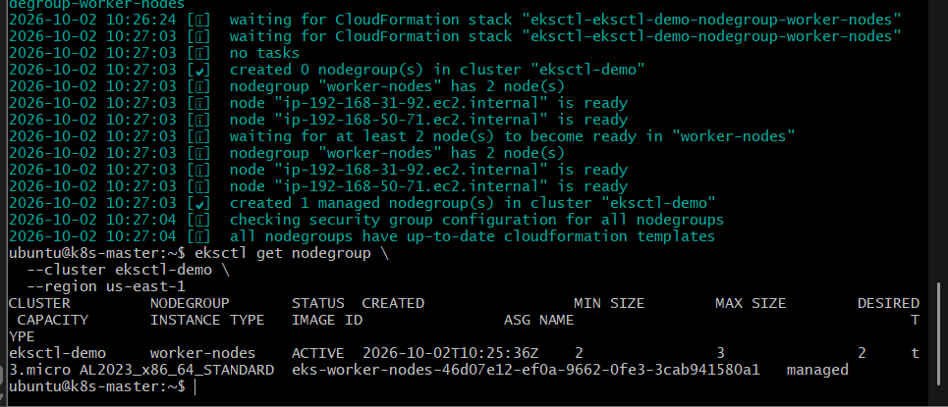
This creates:
AWS
|
+-- EKS Cluster: eksctl-demo
| |
| +-- Kubernetes Control Plane
| |
| +-- Managed Node Group
| |
| +-- Worker Node
| |
| +-- Worker Node
|
+-- VPC
|
+-- Subnets
+-- Security Groups

1.4 Verify the cluster
eksctl get cluster --region us-east-1
Expected:
NAME REGION
eksctl-demo us-east-1

1.5 Verify Kubernetes connectivity
kubectl get nodes
Expected:
NAME STATUS ROLES AGE VERSION
ip-xxx-xxx-xxx-xxx.ec2.internal Ready <none> ... v1.xx.x
ip-xxx-xxx-xxx-xxx.ec2.internal Ready <none> ... v1.xx.x

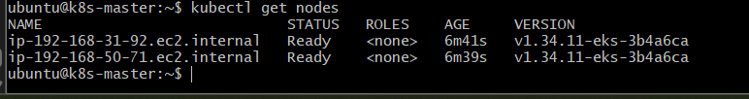

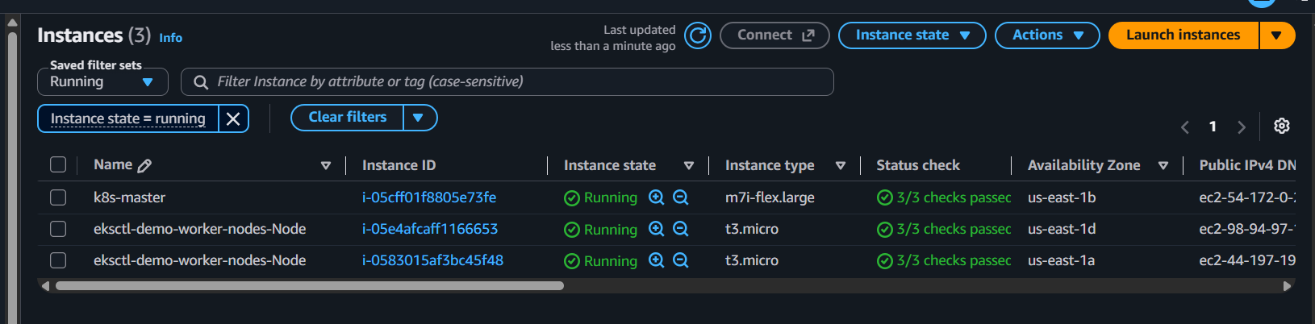

1.6 Check cluster information
kubectl cluster-info
Then:
kubectl get pods -A

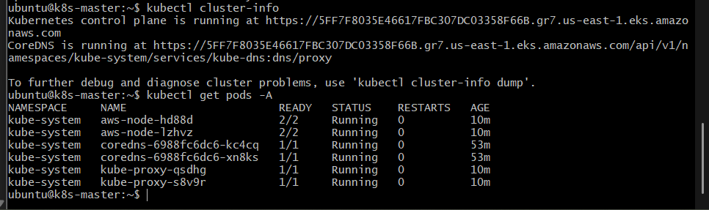
This verifies that the EKS system components are running.

1.7 Deploy a test application
Create an Nginx deployment:
kubectl create deployment nginx --image=nginx
Check:
kubectl get deployment
kubectl get pods
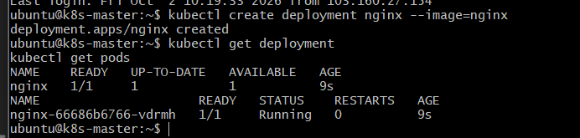
Expose it:
kubectl expose deployment nginx \
--type=LoadBalancer \
--port=80
Check:
kubectl get svc nginx

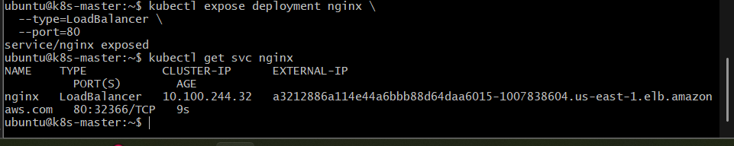
Wait until AWS provisions the external load balancer and an EXTERNAL-IP/hostname appears.

1.8 Validate the application
kubectl get pods -o wide
kubectl get svc nginx

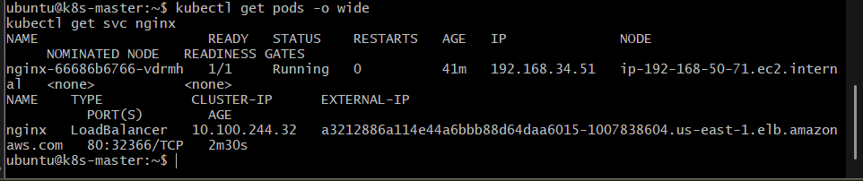
The request flow is:
User
|
| HTTP request
v
AWS Load Balancer
|
v
EKS Service
|
v
Nginx Pod
|
v
Worker Node

Outcome
You will have a working EKS cluster created completely through eksctl, with:
- EKS control plane
- Managed node group
- Two worker nodes
- kubectl connected to the cluster
- Nginx test workload
- AWS Load Balancer exposing the application

Task 2: Setup EKS Cluster Using AWS Console

Objective
Create an Amazon EKS cluster using the AWS Management Console, configure the networking and managed node group, and verify that the Kubernetes cluster is accessible using kubectl.

Implementation Steps

2.1 Open EKS
- Sign in to the AWS Management Console.
- Select region US East (N. Virginia) — us-east-1.
- Search for EKS.
- Open Elastic Kubernetes Service.
- Select Clusters.
- Click Create cluster.

2.2 Configure cluster
Select:
- Creation option: Custom configuration
- Cluster name: eks-console-demo
- Kubernetes version: Select the currently available supported version.
For cluster IAM:
- Select/create an EKS Cluster IAM Role.
- The role needs the required EKS cluster permissions.
- 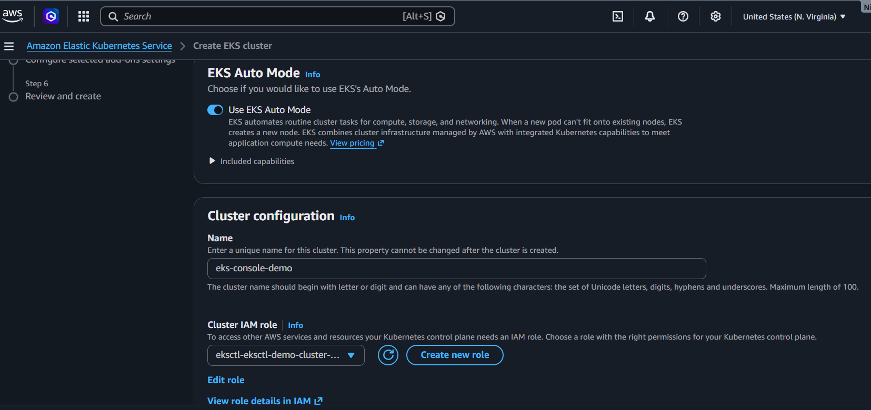
Keep the default logging configuration for this lab unless you specifically want to test control-plane logging.
Click Next.

2.3 Configure networking
Select:
- VPC: Choose an existing suitable VPC or create a new one.
- Subnets: Select multiple subnets in different Availability Zones.
- Security group: Use the automatically created/default EKS security group unless your lab requires a custom one.
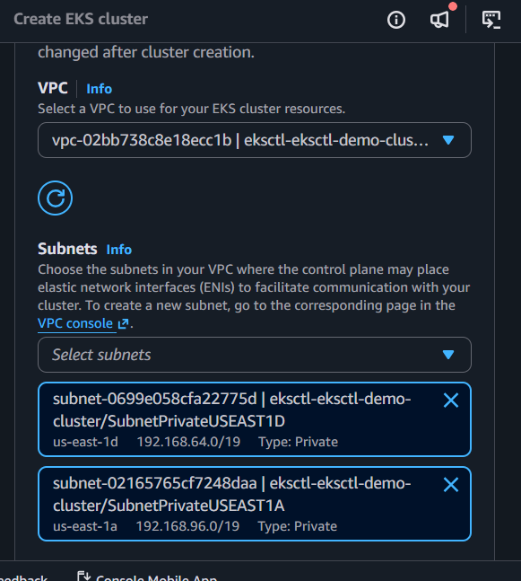
For a basic lab, use at least two Availability Zones.
Click Next.

2.4 Configure cluster endpoint
For the Kubernetes API server endpoint, use:
Public
This makes the Kubernetes API endpoint accessible from your workstation, subject to AWS security controls.
For a production environment, endpoint access should be designed according to your network/security requirements.
Click Next.

2.5 Configure add-ons
Review the EKS add-ons.
Typical add-ons include:
- VPC CNI
- CoreDNS
- kube-proxy
- EKS Pod Identity Agent
Keep the required/default add-ons enabled.
Click Next.

2.6 Review and create
Review:
Cluster name: eks-console-demo
Region: us-east-1
VPC: selected VPC
Subnets: multiple AZs
Endpoint: Public
Add-ons: Enabled
Click Create.
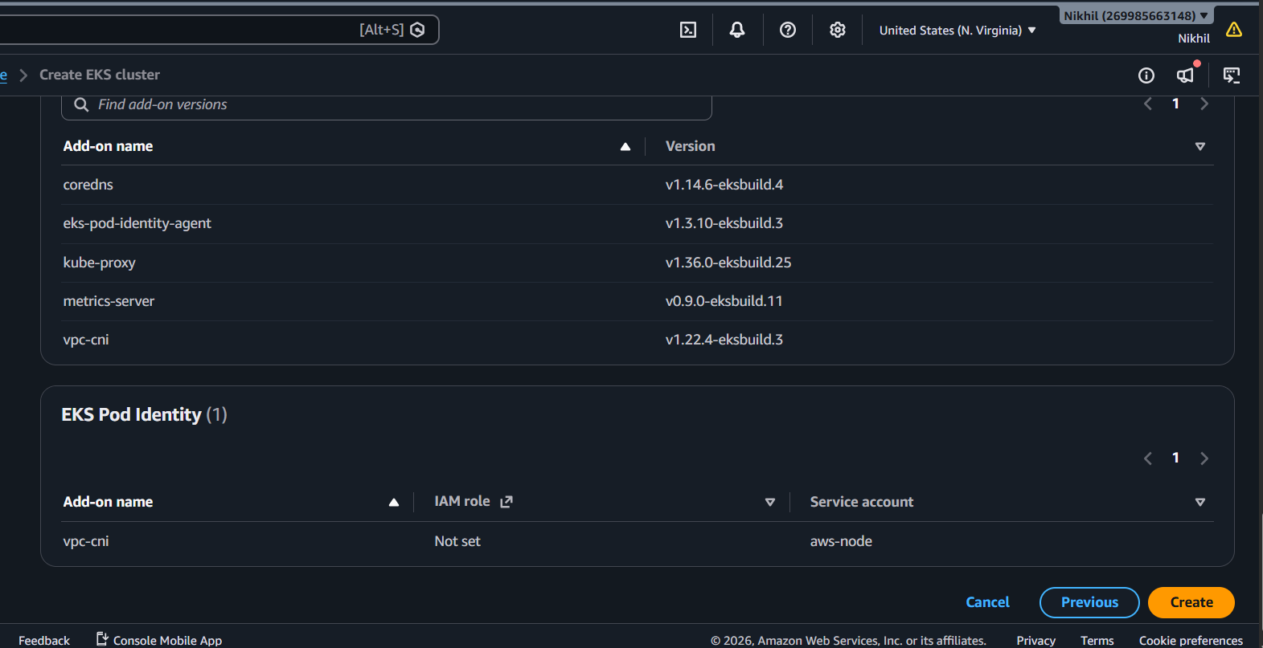
Wait until the cluster status changes:
ACTIVE

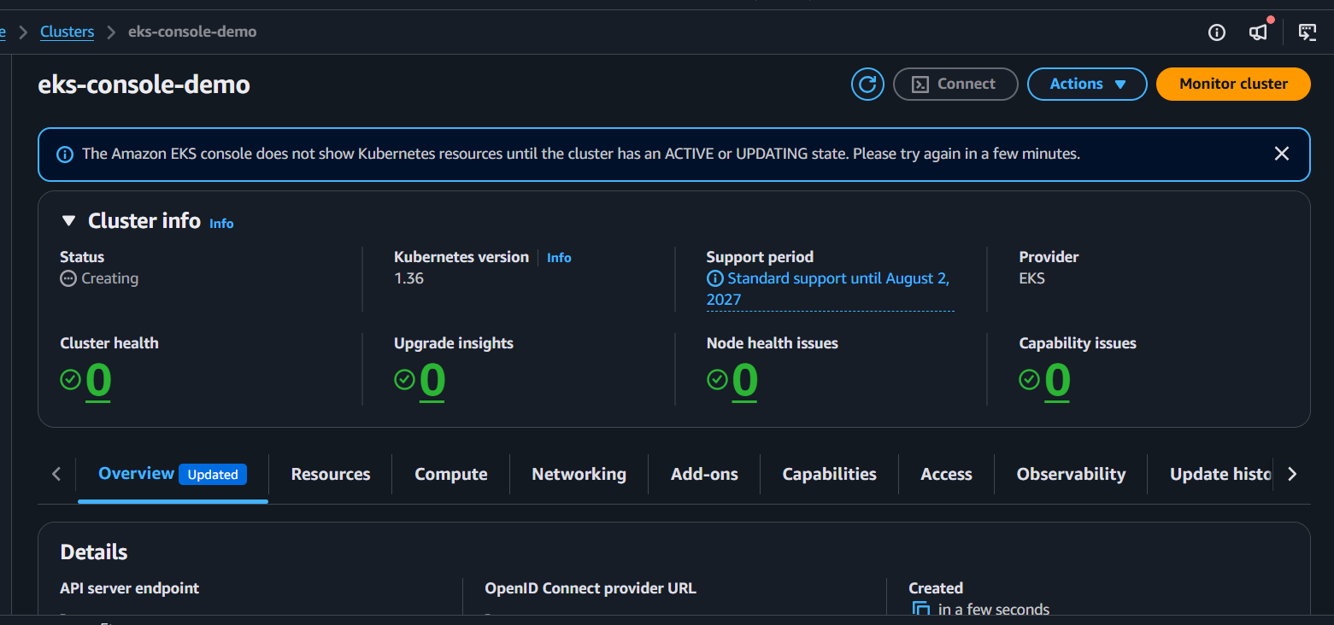

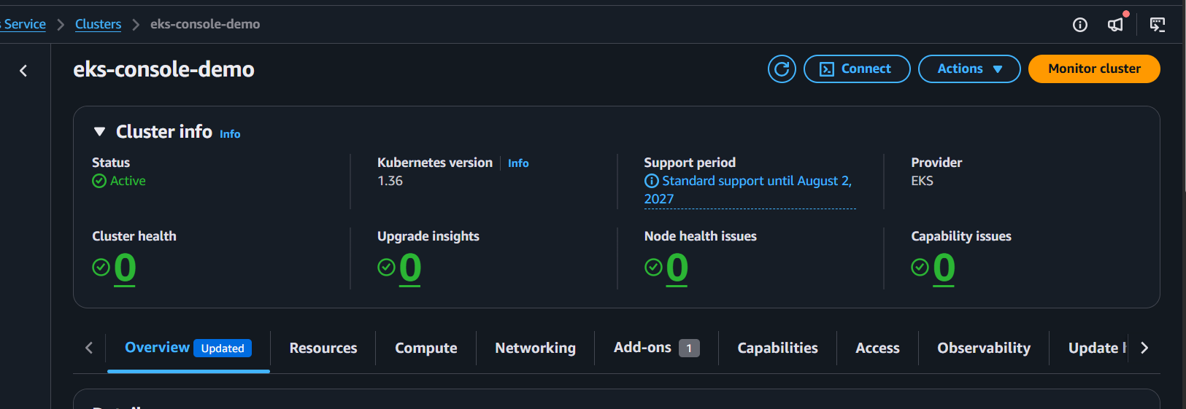

2.7 Create the managed node group
After the cluster becomes active:
- Open:
EKS
→ Clusters
→ eks-console-demo
→ Compute
- Click Add node group.
Configure:
Node group name: worker-nodes
Select/create the required Node IAM role.
The node role needs the appropriate permissions for:
- EKS worker nodes
- ECR image pulling
- VPC CNI networking

2.8 Configure node group compute
For the lab, use:
AMI: Amazon Linux
Instance type: t3.medium
Desired size: 2
Minimum size: 2
Maximum size: 3

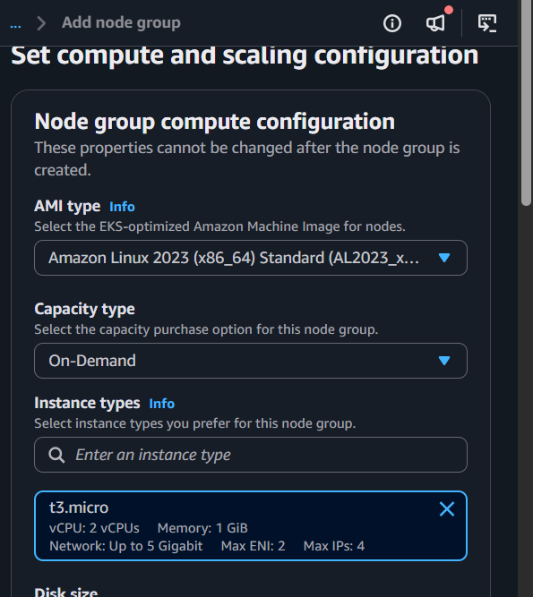

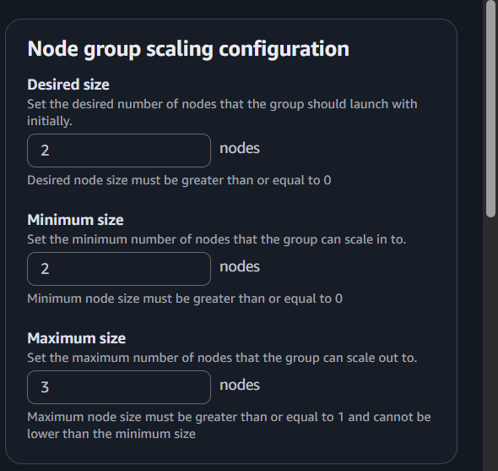
Select subnets in multiple Availability Zones.
Click Create.
Wait until the node group becomes:
ACTIVE

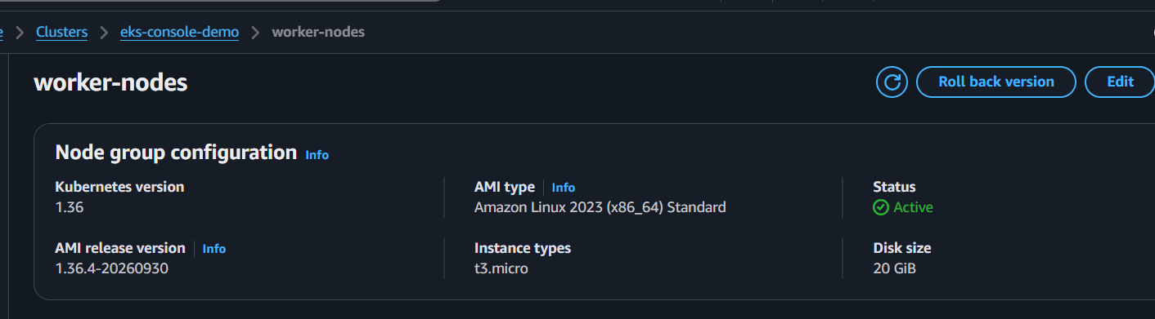

2.9 Configure kubectl
Once the cluster and node group are ready, configure your local kubectl.
Run:
aws eks update-kubeconfig \
--region us-east-1 \
--name eks-console-demo
Verify:
kubectl config current-context

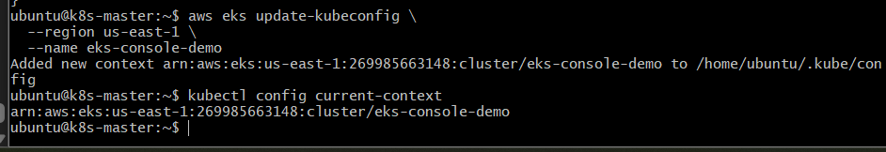

2.10 Verify the cluster
kubectl get nodes
Expected:
NAME STATUS ROLES AGE VERSION
ip-xxx-xxx-xxx-xxx... Ready <none> ... v1.xx.x
ip-xxx-xxx-xxx-xxx... Ready <none> ... v1.xx.x

2.11 Check system pods
kubectl get pods -A
You should see Kubernetes/EKS components such as:
coredns
kube-proxy
aws-node
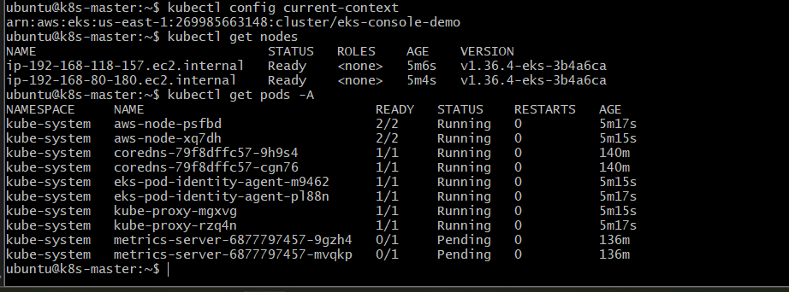

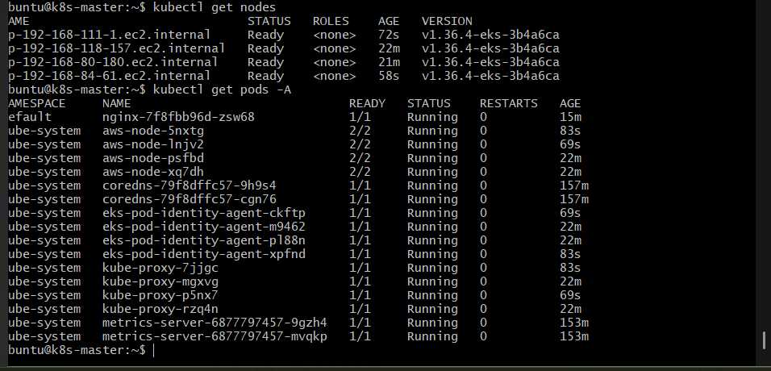

2.12 Deploy a test application
kubectl create deployment nginx --image=nginx

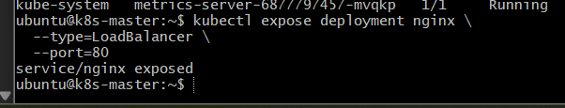
Verify:
kubectl get pods
Expose it:
kubectl expose deployment nginx \
--type=LoadBalancer \
--port=80
Check:
kubectl get svc nginx
Wait for the AWS Load Balancer hostname to appear.
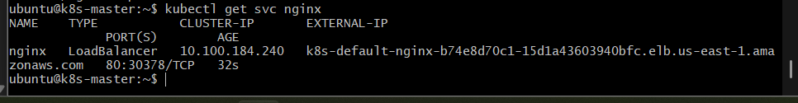

Outcome
You have created an EKS cluster through the AWS Console with:
AWS Console
|
v
EKS Cluster
|
+---- Control Plane
|
+---- VPC
| |
| +---- Subnet AZ-1
| +---- Subnet AZ-2
|
+---- Managed Node Group
|
+---- Worker Node
+---- Worker Node
You also verified:
- EKS cluster is ACTIVE
- Managed node group is ACTIVE
- Worker nodes are Ready
- EKS system pods are running
- kubectl can communicate with the cluster
- Nginx can be deployed to the cluster
- A LoadBalancer Service can expose the application

Task 3 — Setup HPA in EKS

Objective
Create a Horizontal Pod Autoscaler (HPA) that automatically increases or decreases the number of application pods based on CPU utilization.

Implementation Steps

3.1 Verify Metrics Server
Run:
kubectl get pods -n kube-system | grep metrics-server
Expected:
metrics-server-xxxxx 1/1 Running
metrics-server-yyyyy 1/1 Running

3.2 Verify Metrics API
Run:
kubectl top nodes
Expected output similar to:
NAME CPU(cores) CPU% MEMORY(bytes) MEMORY%
ip-192-168-... 50m 2% 300Mi 32%
ip-192-168-... 40m 2% 280Mi 30%
If this works, HPA can obtain resource metrics.
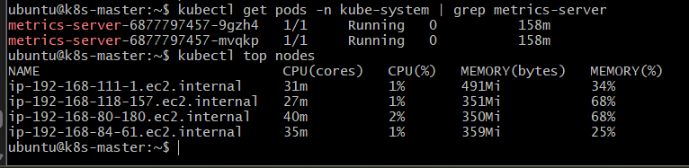

3.3 Create an application deployment
Create:
vi hpa-deployment.yaml
Add:
apiVersion: apps/v1
kind: Deployment
metadata:
name: hpa-demo
spec:
replicas: 2
selector:
matchLabels:
app: hpa-demo
template:
metadata:
labels:
app: hpa-demo
spec:
containers:
- name: nginx
image: nginx
resources:
requests:
cpu: 100m
limits:
cpu: 200m
ports:
- containerPort: 80

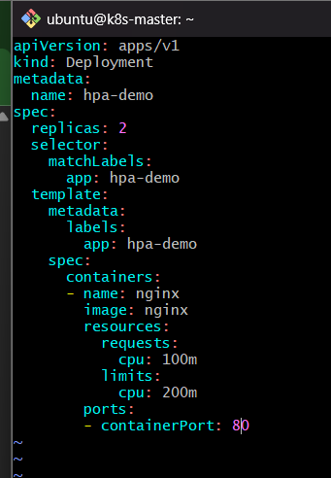
Apply:
kubectl apply -f hpa-deployment.yaml
Verify:
kubectl get pods
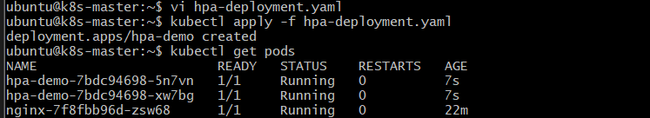

3.4 Create the HPA
Run:
kubectl autoscale deployment hpa-demo \
--cpu-percent=50 \
--min=2 \
--max=5
This means:
Minimum replicas = 2
Maximum replicas = 5
Target CPU = 50%
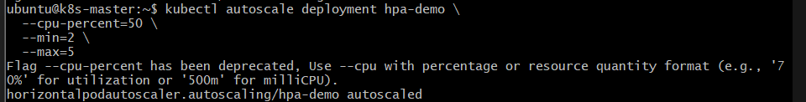
Verify:
kubectl get hpa
Expected:
NAME REFERENCE TARGETS MINPODS MAXPODS REPLICAS
hpa-demo Deployment/hpa-demo .../50% 2 5 2

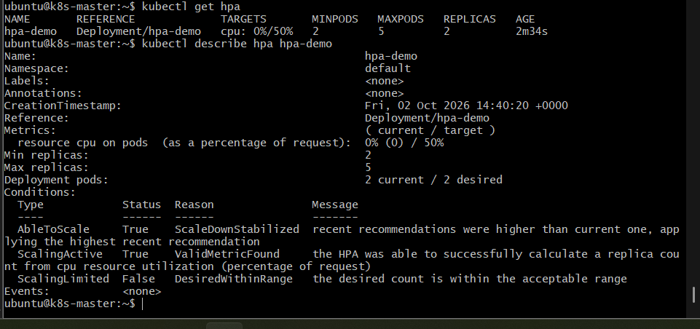

Outcome
The HPA is configured so Kubernetes can automatically scale hpa-demo between 2 and 5 pods based on CPU utilization.

Task 4 — Setup Cluster Autoscaler

Objective
Configure Cluster Autoscaler for the eks-console-demo EKS cluster so that the number of worker nodes can automatically increase or decrease based on pod scheduling requirements.

Implementation Steps

4.1 — Start the worker nodes
first increase the managed node group's desired size back to 2.
In the AWS Console:
EKS → Clusters → eks-console-demo → Compute → Node groups → your node group → Update
Set:
Desired size: 2
Minimum size: 1
Maximum size: 3
Wait until the node group becomes ACTIVE and verify:
kubectl get nodes
You should see your worker nodes as:
STATUS
Ready

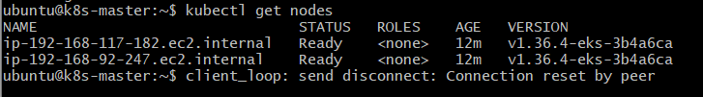

4.2 — Verify the cluster
Run:
kubectl get nodes
kubectl get pods -A
Make sure the existing system pods are running.
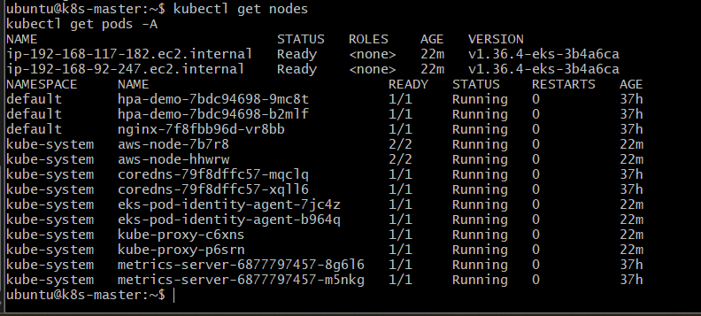

4.3 — Create IAM permissions for Cluster Autoscaler
For EKS, Cluster Autoscaler needs permission to query and modify the Auto Scaling Group behind the managed node group.
Before creating anything, let's check whether your cluster already has an appropriate IAM role/policy setup.
Run:
aws eks describe-nodegroup \
--cluster-name eks-console-demo \
--nodegroup-name worker-nodes \
--query "nodegroup.nodeRole" \
--output text
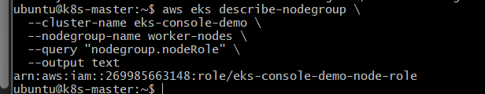

4.4 — Add Cluster Autoscaler permissions
For this lab, we'll add a minimal inline IAM policy to the existing node role.
Create the policy file:
nano cluster-autoscaler-policy.json
Add:
{
"Version": "2012-10-17",
"Statement": [
{
"Effect": "Allow",
"Action": [
"autoscaling:DescribeAutoScalingGroups",
"autoscaling:DescribeAutoScalingInstances",
"autoscaling:DescribeLaunchConfigurations",
"autoscaling:DescribeScalingActivities",
"autoscaling:DescribeTags",
"autoscaling:SetDesiredCapacity",
"autoscaling:TerminateInstanceInAutoScalingGroup"
],
"Resource": "*"
}
]
}
Save and exit.
Then attach it to your node role:
aws iam put-role-policy \
--role-name eks-console-demo-node-role \
--policy-name ClusterAutoscalerPolicy \
--policy-document file://cluster-autoscaler-policy.json
Verify:
aws iam get-role-policy \
--role-name eks-console-demo-node-role \
--policy-name ClusterAutoscalerPolicy
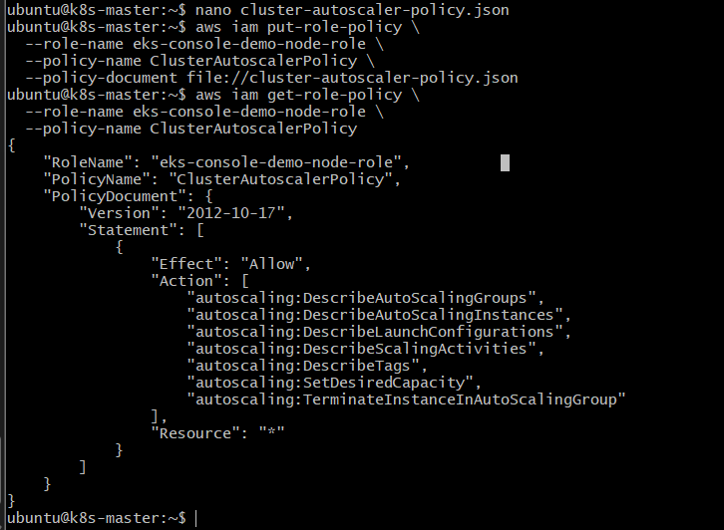

4.5 — Identify the Auto Scaling Group
Now we need to find the Auto Scaling Group (ASG) associated with your EKS managed node group.
Run:
aws eks describe-nodegroup \
--cluster-name eks-console-demo \
--nodegroup-name worker-nodes \
--query "nodegroup.resources.autoScalingGroups[*].name" \
--output text

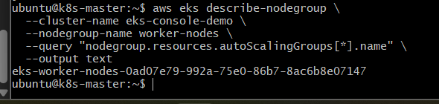

4.6 — Check Cluster Autoscaler discovery tags
Cluster Autoscaler uses AWS Auto Scaling tags to discover which node groups it should manage.
Run:
aws autoscaling describe-auto-scaling-groups \
--auto-scaling-group-names eks-worker-nodes-0ad07e79-992a-75e0-86b7-8ac6b8e07147 \
--query "AutoScalingGroups[0].Tags" \
--output table
Look for these two tags:
k8s.io/cluster-autoscaler/enabled
k8s.io/cluster-autoscaler/eks-console-demo
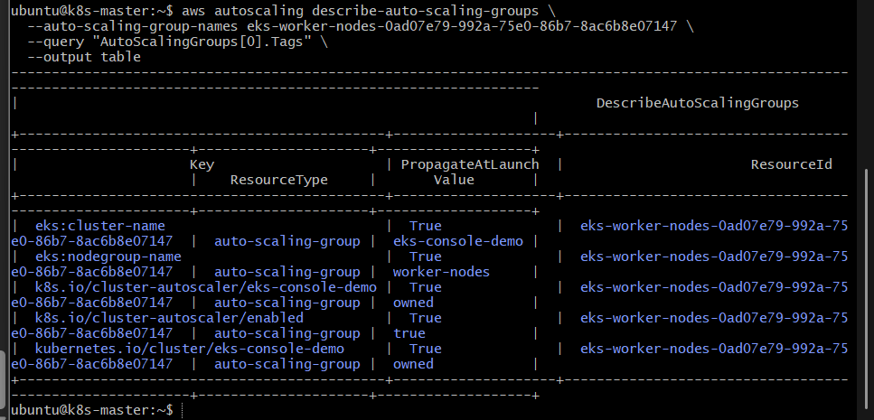

4.7 — Install Cluster Autoscaler
Before installing it, we need to use a Cluster Autoscaler version compatible with your EKS Kubernetes version.
Run:
aws eks describe-cluster \
--name eks-console-demo \
--query "cluster.version" \
--output text
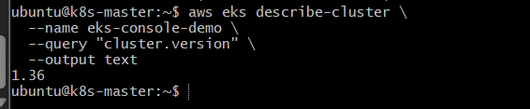

Run:
wget https://raw.githubusercontent.com/kubernetes/autoscaler/master/cluster-autoscaler/cloudprovider/aws/examples/cluster-autoscaler-autodiscover.yaml
Then check that the file exists:
ls -l cluster-autoscaler-autodiscover.yaml
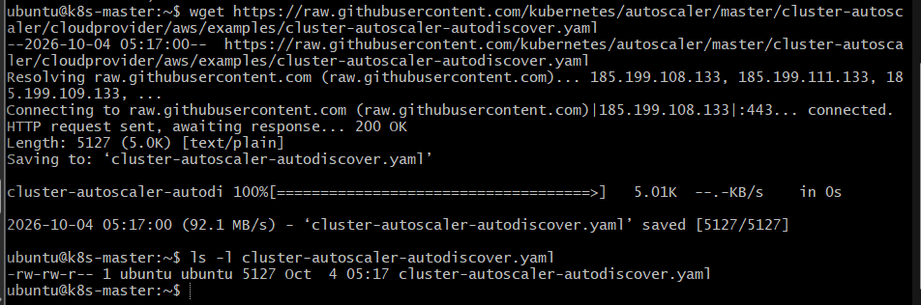

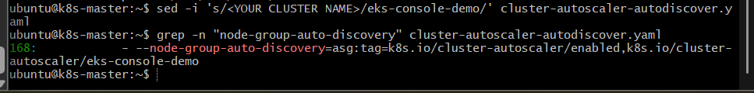
Now run:
kubectl apply -f cluster-autoscaler-autodiscover.yaml
Then verify:
kubectl get pods -n kube-system | grep cluster-autoscaler
You should see a pod with status:
Running
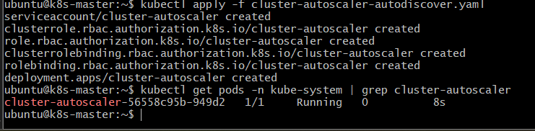

4.8 — Verify Cluster Autoscaler
Now check its logs:
kubectl logs -n kube-system deployment/cluster-autoscaler --tail=50
Look for messages indicating:
Registering asg
or:
Regenerating instance to ASG map
and that it discovered your node group.
Also run:
kubectl get deployment cluster-autoscaler -n kube-system

Step 4.9 — Validate Cluster Autoscaler
Run:
kubectl logs -n kube-system deployment/cluster-autoscaler --tail=30
Look for messages such as:
Regenerating instance to ASG map
and importantly, no ERROR, FATAL, or Failed to create AWS Manager messages.
Also run:
kubectl get deployment cluster-autoscaler -n kube-system
Expected:
NAME READY UP-TO-DATE AVAILABLE
cluster-autoscaler 1/1 1 1
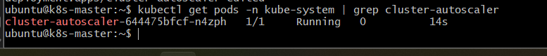

Final validation
kubectl get deployment cluster-autoscaler -n kube-system
Final output:
NAME READY UP-TO-DATE AVAILABLE
cluster-autoscaler 1/1 1 1
This confirms that the Cluster Autoscaler deployment is healthy.
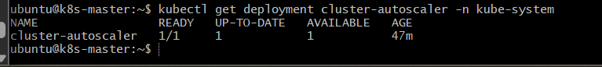

Outcome
Cluster Autoscaler was successfully configured on the EKS cluster.
The final setup is:
EKS Cluster
|
v
Cluster Autoscaler
|
| EKS Pod Identity
v
EKSClusterAutoscalerRole
|
v
AWS Auto Scaling API
|
v
EKS Managed Node Group
|
v
EC2 Instances
The Cluster Autoscaler is now able to:
- Discover the EKS Auto Scaling Groups.
- Detect unschedulable pods.
- Request additional EC2 worker nodes when required.
- Remove unnecessary nodes when allowed.
- Respect the node group's minimum and maximum size.
- Authenticate to AWS using EKS Pod Identity.
Final validation:
cluster-autoscaler 1/1 1 1

Task 5: Setup Kubernetes Job and CronJob on EKS

1. Objective
To create and execute:
- A Job — runs a task to completion.
- A CronJob — runs Jobs automatically according to a schedule.
The goal is to understand how Kubernetes handles one-time tasks and scheduled tasks.

2. Implementation Steps

2.1 Create a Kubernetes Job
Create the YAML file:
nano job.yaml
Add:
apiVersion: batch/v1
kind: Job
metadata:
name: demo-job
spec:
completions: 1
parallelism: 1
template:
spec:
restartPolicy: Never
containers:
- name: job-container
image: busybox
command:
- sh
- -c
- "echo Job started; sleep 10; echo Job completed"
Apply it:
kubectl apply -f job.yaml

2.2 Verify the Job
kubectl get jobs
Expected:
NAME COMPLETIONS DURATION AGE
demo-job 1/1 ... ...
Check the pod:
kubectl get pods
The pod should eventually show:
Completed
Check the output:
kubectl logs job/demo-job
Expected:
Job started
Job completed
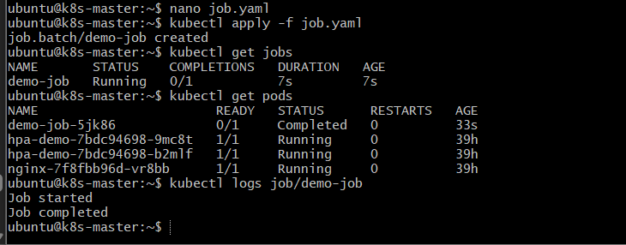

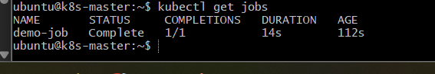

2.3 Create a CronJob
Create:
nano cronjob.yaml
Add:
apiVersion: batch/v1
kind: CronJob
metadata:
name: demo-cronjob
spec:
schedule: "*/2 * * * *"
jobTemplate:
spec:
template:
spec:
restartPolicy: Never
containers:
- name: cronjob-container
image: busybox
command:
- sh
- -c
- "echo CronJob executed at $(date)"
Apply it:
kubectl apply -f cronjob.yaml

2.4 Verify the CronJob
kubectl get cronjobs
Expected:
NAME SCHEDULE SUSPEND ACTIVE LAST SCHEDULE
demo-cronjob */2 * * * * False 0 ...
The schedule:
*/2 * * * *
means:
Run the CronJob every 2 minutes.
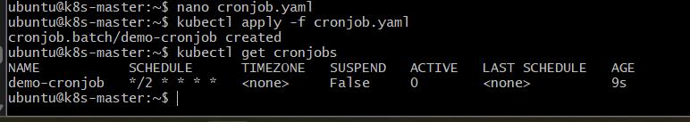

2.5 Verify the Jobs created by the CronJob
Wait for the scheduled execution and run:
kubectl get jobs
You should see both the original Job and a Job created by the CronJob:
NAME COMPLETIONS
demo-job 1/1
demo-cronjob-xxxxxxxx 1/1
Check the CronJob pod:
kubectl get pods
Then view its output:
kubectl logs <cronjob-pod-name>
Expected output will be similar to:
CronJob executed at Sun Oct 04 06:xx:xx UTC 2026
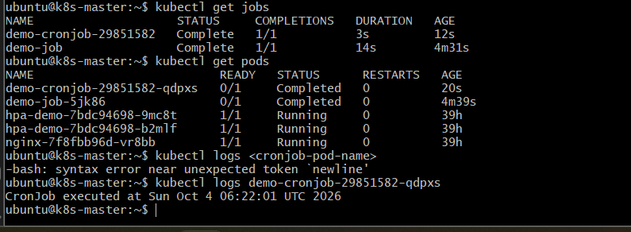

3. Outcome
You successfully created:
Job:
Job
|
v
Pod
|
v
Task executes once
|
v
Completed
CronJob:
CronJob
|
| Schedule
v
Job
|
v
Pod
|
v
Task executes

Task 6: Create Secret and Inject It Inside a Pod

1. Objective
To create a Kubernetes Secret and securely inject its values into a Pod as environment variables.
We will create a Secret containing a username and password, then make those values available inside an Nginx Pod.

2. Implementation Steps

2.1 Create the Secret
Create a Secret YAML file:
nano secret.yaml
Add:
apiVersion: v1
kind: Secret
metadata:
name: app-secret
type: Opaque
stringData:
username: admin
password: mypassword123
Apply it:
kubectl apply -f secret.yaml
Expected:
secret/app-secret created

2.2 Verify the Secret
kubectl get secret app-secret
Expected:
NAME TYPE DATA AGE
app-secret Opaque 2 ...
You can also check:
kubectl describe secret app-secret
You will see the keys:
Data
====
password: 14 bytes
username: 5 bytes
The actual values are not displayed by describe.
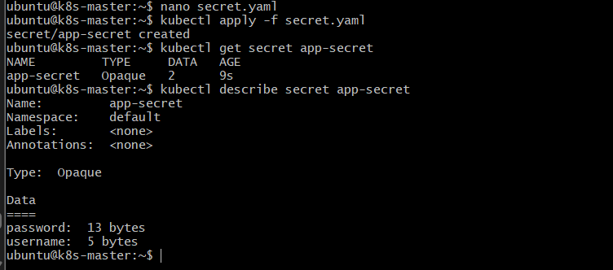

2.3 Create a Pod and inject the Secret
Create:
nano secret-pod.yaml
Add:
apiVersion: v1
kind: Pod
metadata:
name: secret-pod
spec:
containers:
- name: nginx
image: nginx
env:
- name: APP_USERNAME
valueFrom:
secretKeyRef:
name: app-secret
key: username
- name: APP_PASSWORD
valueFrom:
secretKeyRef:
name: app-secret
key: password
Apply:
kubectl apply -f secret-pod.yaml
Expected:
pod/secret-pod created

2.4 Verify the Pod
kubectl get pod secret-pod
Expected:
NAME READY STATUS RESTARTS AGE
secret-pod 1/1 Running 0 ...
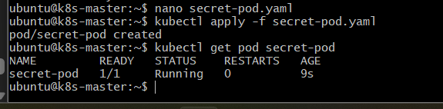

2.5 Verify Secret values inside the Pod
Run:
kubectl exec secret-pod -- env | grep APP_
Expected:
APP_USERNAME=admin
APP_PASSWORD=mypassword123
This confirms that the Kubernetes Secret has been injected into the container as environment variables.
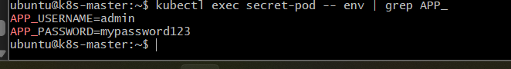

3. Outcome
The final flow is:
Secret
|
| username/password
v
Pod specification
|
| secretKeyRef
v
Container environment variables
|
v
Application

Task 7: Check Different Add-ons Available on EKS

1. Objective
To identify and understand the Amazon EKS add-ons available for an EKS cluster and verify which add-ons are currently installed and active.
EKS add-ons provide AWS-supported components that extend the functionality of the Kubernetes cluster.

2. Implementation Steps

2.1 List the add-ons currently installed
Run:
aws eks list-addons \
--cluster-name eks-console-demo \
--region us-east-1
Expected output will look similar to:
{
"addons": [
"kube-proxy",
"vpc-cni",
"coredns",
"eks-pod-identity-agent"
]
}
The exact list may differ depending on your cluster configuration.
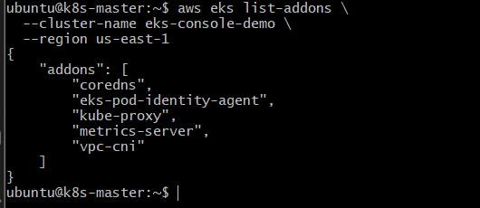

2.2 Check the status of installed add-ons
Run:
aws eks describe-addon \
--cluster-name eks-console-demo \
--addon-name vpc-cni \
--region us-east-1
Look for:
status: ACTIVE
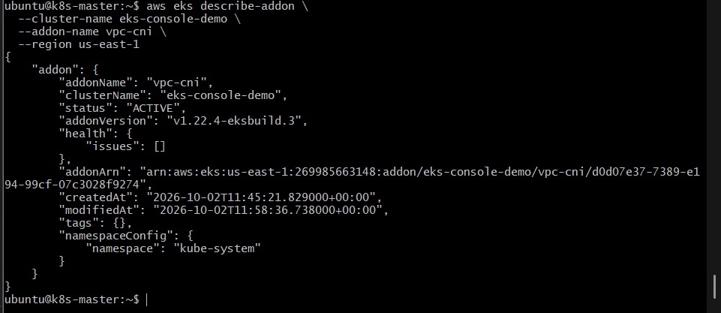
You can repeat the command for other installed add-ons:
aws eks describe-addon \
--cluster-name eks-console-demo \
--addon-name coredns \
--region us-east-1
and:
aws eks describe-addon \
--cluster-name eks-console-demo \
--addon-name kube-proxy \
--region us-east-1
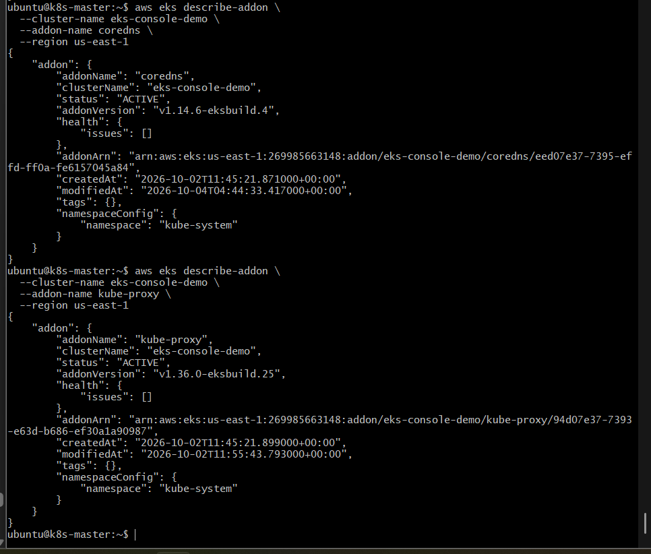

2.3 List all add-ons supported for the EKS version
First check the Kubernetes version:
aws eks describe-cluster \
--name eks-console-demo \
--region us-east-1 \
--query "cluster.version" \
--output text
Then list the available EKS add-ons:
aws eks describe-addon-versions \
--kubernetes-version 1.36 \
--region us-east-1 \
--query "addons[*].addonName" \
--output text
This shows the add-ons that can be used with Kubernetes 1.36.
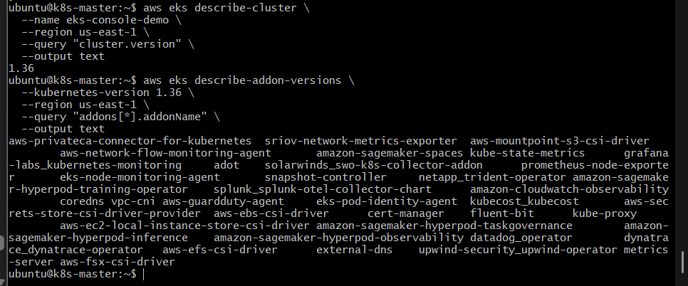

2.4 Check add-ons from Kubernetes
You can also verify the components from Kubernetes:
kubectl get pods -n kube-system
You should see components such as:
aws-node
coredns
kube-proxy
eks-pod-identity-agent
For example:
kubectl get pods -n kube-system -l k8s-app=kube-dns
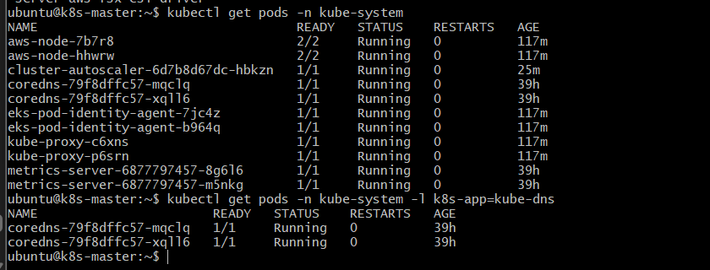
This verifies the CoreDNS pods.

2.5 Understand the important EKS add-ons
Add-on | Purpose
Amazon VPC CNI | Provides networking for Kubernetes Pods using AWS VPC networking
CoreDNS | Provides DNS-based service discovery inside the cluster
kube-proxy | Maintains Kubernetes network rules for Services
EKS Pod Identity Agent | Allows Pods to obtain AWS IAM permissions through EKS Pod Identity
Amazon EBS CSI Driver | Allows Kubernetes to dynamically provision and attach EBS volumes
Amazon EFS CSI Driver | Allows Pods to use Amazon EFS storage
Metrics Server | Provides CPU/memory metrics used by HPA

2.6 Check whether the EBS CSI Driver is installed
Run:
aws eks list-addons \
--cluster-name eks-console-demo \
--region us-east-1
If you see:
aws-ebs-csi-driver
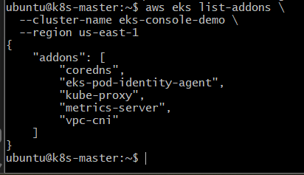
check its status:
aws eks describe-addon \
--cluster-name eks-console-demo \
--addon-name aws-ebs-csi-driver \
--region us-east-1 \
--query "addon.status" \
--output text
Expected:
ACTIVE
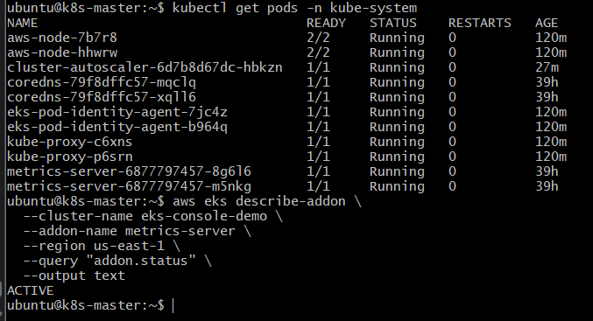

2.7 Check Pod Identity Agent
Since we used EKS Pod Identity for Cluster Autoscaler, verify the agent:
kubectl get pods -n kube-system -l app.kubernetes.io/name=eks-pod-identity-agent
Expected:
NAME READY STATUS
eks-pod-identity-agent-xxxxx 1/1 Running
eks-pod-identity-agent-yyyyy 1/1 Running
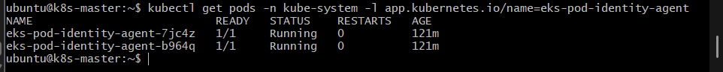
This confirms the Pod Identity Agent is running on the worker nodes.

3. Outcome
You have verified the EKS add-on mechanism and learned the purpose of the major EKS add-ons.
The important architecture is:
EKS Cluster
|
+---------------+---------------+
| | |
v v v
VPC CNI CoreDNS kube-proxy
| | |
Pod Network Pod DNS Service Network
|
|
+------------------------------+
|
v
EKS Pod Identity
|
v
IAM Role
For storage:
Pod
|
v
PVC
|
v
EBS CSI Driver
|
v
Amazon EBS Volume

Task 8: Upgrade EKS Cluster

1. Objective
To upgrade the Kubernetes version of the EKS cluster from 1.36 to 1.37 and then upgrade the worker nodes, Cluster Autoscaler, and EKS add-ons to versions compatible with the new cluster version.

2. Implementation Steps

2.1 Verify the current cluster version
Run:
aws eks describe-cluster \
--name eks-console-demo \
--region us-east-1 \
--query "cluster.version" \
--output text
Expected:
1.36
Verify the worker nodes:
kubectl get nodes
You should currently see nodes running Kubernetes 1.36.x.

2.2 Check the EKS cluster health
Run:
aws eks describe-cluster \
--name eks-console-demo \
--region us-east-1 \
--query "cluster.status" \
--output text
Expected:
ACTIVE
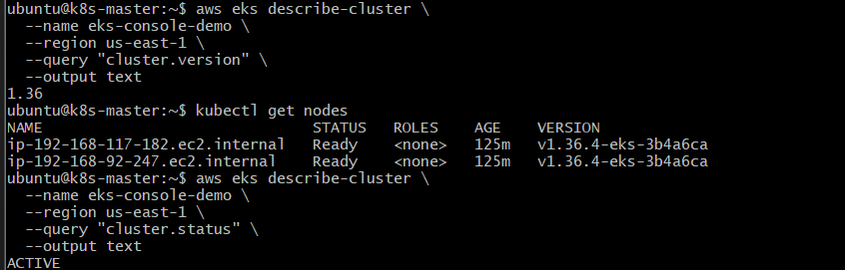
Also check:
kubectl get nodes
kubectl get pods -A
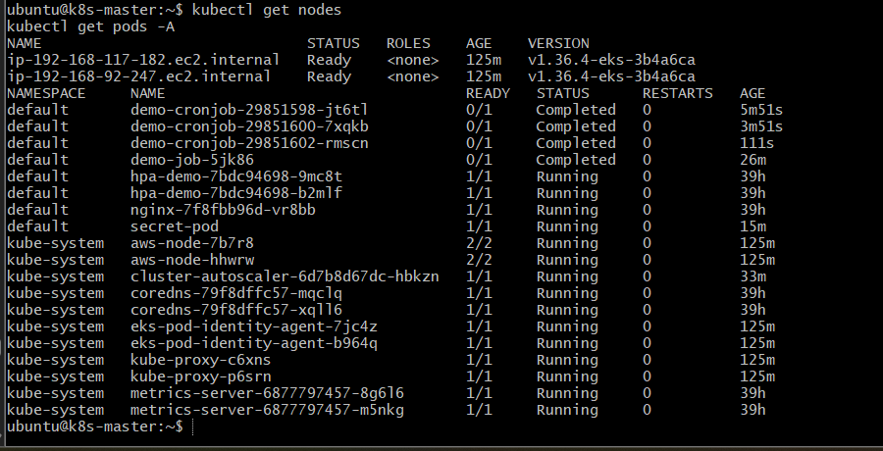
All important system components should be healthy before starting the upgrade.
AWS recommends checking cluster upgrade readiness and upgrade insights before upgrading.

2.3 Check the node groups
Run:
aws eks list-nodegroups \
--cluster-name eks-console-demo \
--region us-east-1
You may see:
[
"worker-nodes",
"hpa-worker-nodes"
]
Both node groups need to be considered during the upgrade.
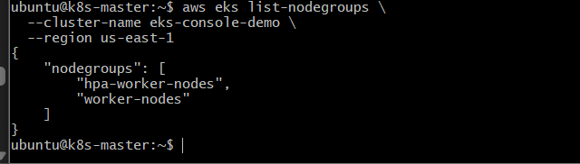

2.4 Upgrade the EKS control plane
Use AWS CLI:
aws eks update-cluster-version \
--name eks-console-demo \
--kubernetes-version 1.37 \
--region us-east-1
AWS returns an update ID, for example:
{
"update": {
"id": "xxxxxxxx-xxxx-xxxx-xxxx-xxxxxxxxxxxx",
"status": "InProgress",
"type": "VersionUpdate"
}
}
The control-plane upgrade cannot simply be paused once started. EKS performs health checks during the update.
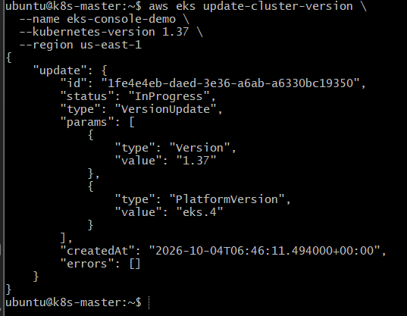

2.5 Monitor the control-plane upgrade
Use the update ID returned from the previous command:
aws eks describe-update \
--name eks-console-demo \
--region us-east-1 \
--update-id <UPDATE-ID>
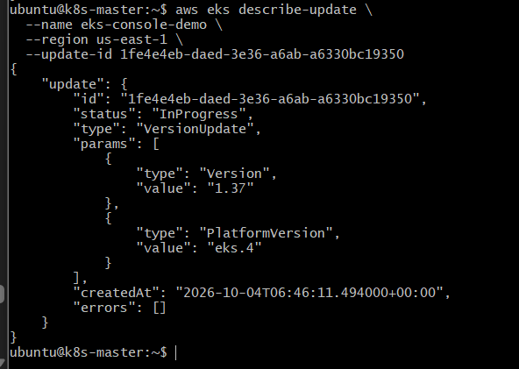
Continue checking until:
status: Successful

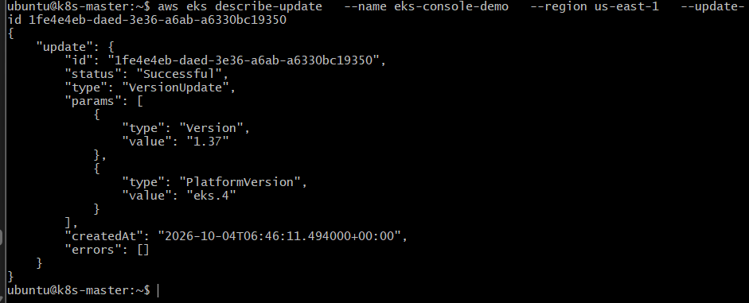
You can also check:
aws eks describe-cluster \
--name eks-console-demo \
--region us-east-1 \
--query "cluster.version" \
--output text
Expected:
1.37
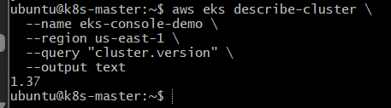

3. Upgrade the Managed Node Groups
After the control plane reaches 1.37, upgrade the worker nodes.
AWS recommends updating managed node groups to match the control-plane Kubernetes version. During managed node-group updates, EKS drains nodes before replacing them.

3.1 Upgrade worker-nodes
aws eks update-nodegroup-version \
--cluster-name eks-console-demo \
--nodegroup-name worker-nodes \
--kubernetes-version 1.37 \
--region us-east-1

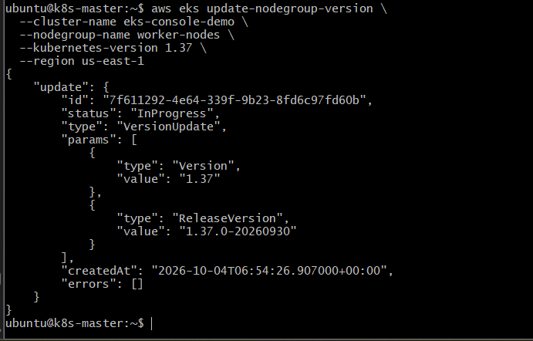
Monitor:
aws eks describe-nodegroup \
--cluster-name eks-console-demo \
--nodegroup-name worker-nodes \
--region us-east-1 \
--query "nodegroup.status" \
--output text
Wait for:
ACTIVE
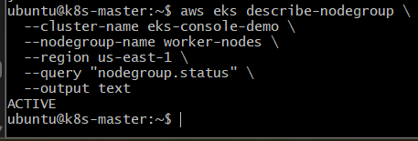

3.2 Upgrade hpa-worker-nodes
Because your Cluster Autoscaler logs showed this second node group, upgrade it as well:
aws eks update-nodegroup-version \
--cluster-name eks-console-demo \
--nodegroup-name hpa-worker-nodes \
--kubernetes-version 1.37 \
--region us-east-1
Check:
aws eks describe-nodegroup \
--cluster-name eks-console-demo \
--nodegroup-name hpa-worker-nodes \
--region us-east-1 \
--query "nodegroup.status" \
--output text
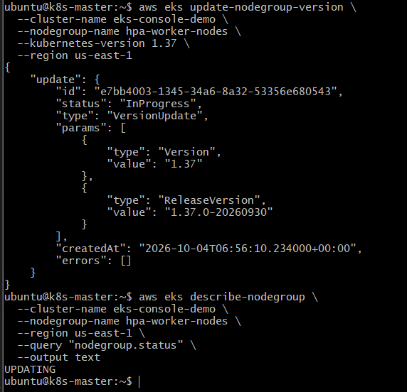
Expected:
ACTIVE
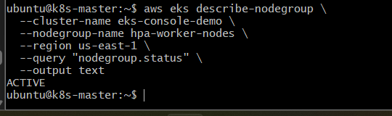

4. Verify Worker Nodes
Run:
kubectl get nodes
Expected:
NAME STATUS ROLES VERSION
ip-192-168-xxx-xxx... Ready <none> v1.37.x
ip-192-168-xxx-xxx... Ready <none> v1.37.x
The important point is that the control plane and worker nodes are now on 1.37.
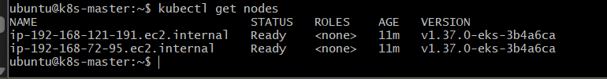

5. Update Cluster Autoscaler
Your current Cluster Autoscaler is:
v1.32.1
After upgrading Kubernetes, AWS recommends updating Cluster Autoscaler to a release matching the new Kubernetes major/minor version.
For this lab, update the Cluster Autoscaler image from:
v1.32.1
to a compatible v1.37.x release.
Before changing it, verify:
kubectl get deployment cluster-autoscaler \
-n kube-system \
-o jsonpath='{.spec.template.spec.containers[0].image}'
After updating, verify that the new pod is healthy:
kubectl get pods -n kube-system -l app=cluster-autoscaler
Expected:
READY STATUS
1/1 Running
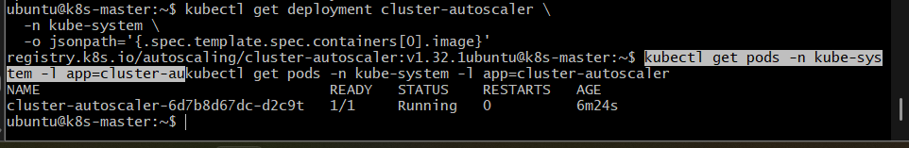
Then:
kubectl logs -n kube-system deployment/cluster-autoscaler --tail=30
You should not see authentication, region, or permission errors.

6. Update EKS Add-ons
Your current add-ons are:
coredns
eks-pod-identity-agent
kube-proxy
metrics-server
vpc-cni
After the Kubernetes upgrade, check their versions:
aws eks list-addons \
--cluster-name eks-console-demo \
--region us-east-1
Then check each add-on:
aws eks describe-addon \
--cluster-name eks-console-demo \
--addon-name vpc-cni \
--region us-east-1 \
--query "addon.addonVersion" \
--output text
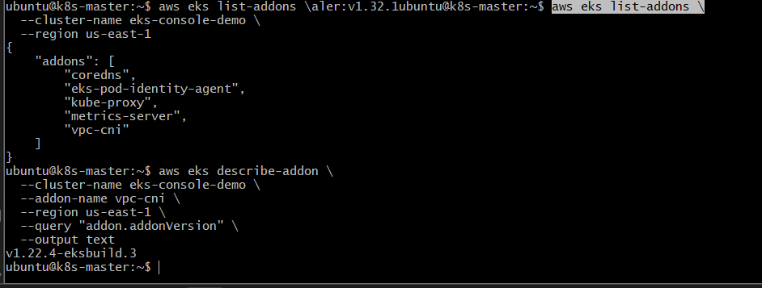
Repeat for:
coredns
kube-proxy
eks-pod-identity-agent
metrics-server
The exact recommended add-on versions should be selected for your EKS 1.37 cluster rather than blindly reusing the old versions.

7. Final Validation
Check the cluster:
kubectl get nodes
Check all Pods:
kubectl get pods -A
Check add-ons:
aws eks list-addons \
--cluster-name eks-console-demo \
--region us-east-1
Check Cluster Autoscaler:
kubectl get deployment cluster-autoscaler -n kube-system
Expected:
NAME READY UP-TO-DATE AVAILABLE
cluster-autoscaler 1/1 1 1
Check HPA from Task 3:
kubectl get hpa
Check the CronJob from Task 5 if it still exists:
kubectl get cronjobs
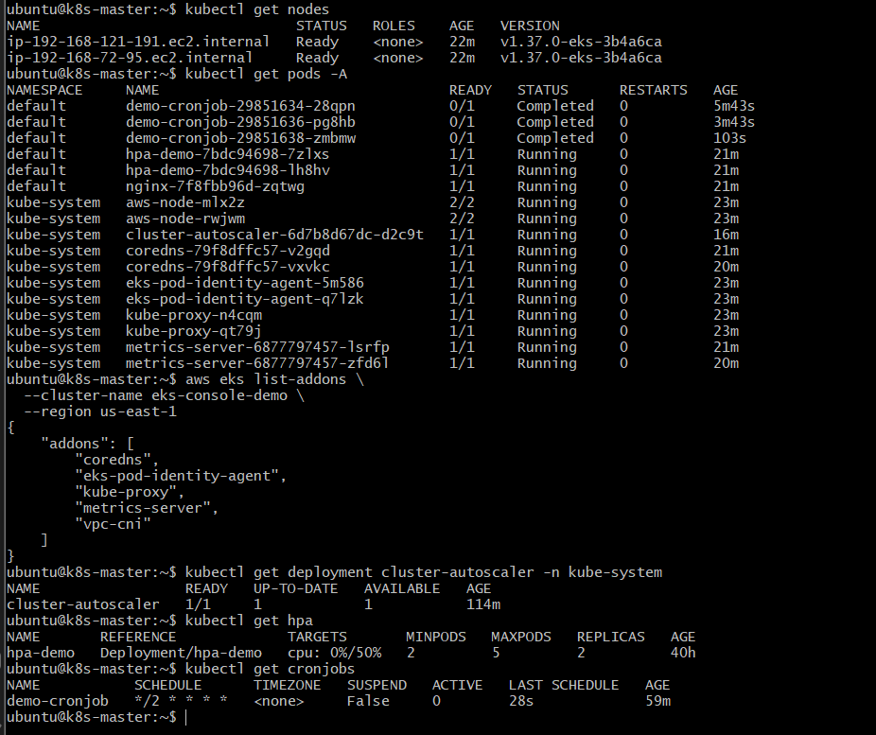

8. Outcome
The final architecture becomes:
EKS Cluster
Kubernetes 1.37
|
+------------+------------+
| |
v v
Control Plane Worker Nodes
1.37 1.37
|
+------------+------------+
| |
v v
Application Pods System Pods
|
+-------------------+----------------+
| | | | |
v v v v v
VPC-CNI CoreDNS kube-proxy Pod Metrics
Identity Server

